

The theme of our project is to make our roads safer. This would be only possible when every person takes initiative that they would not drive without LICENSE, they would not drive if they are drunk or unwell.

**HERE IS MY IDEA**

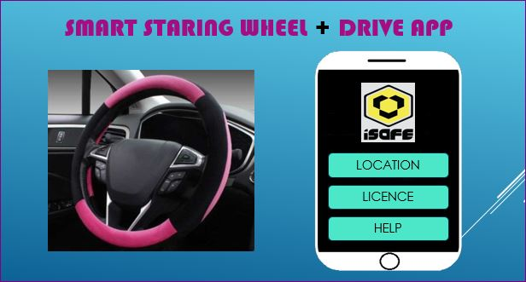

Design of the Smart Staring Wheel

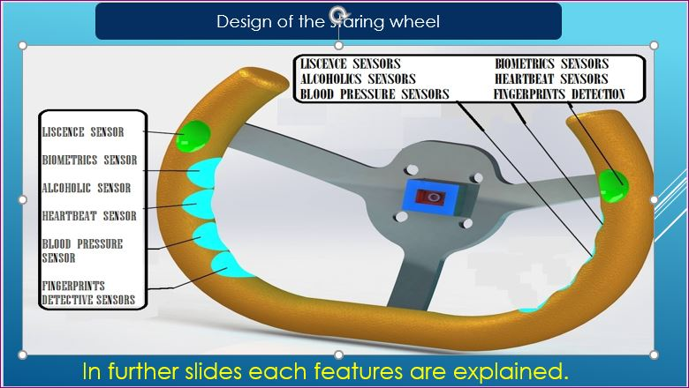

Smart digital Driving licence

In this new initiative of the project all the people have to update their license digitally. In which every people have to provide their biometrics identity which will include fingerprints, photograph, iris image, normal blood pressure, their full address, phone number, e-mail id. All these details will be saved in Indian government database center.

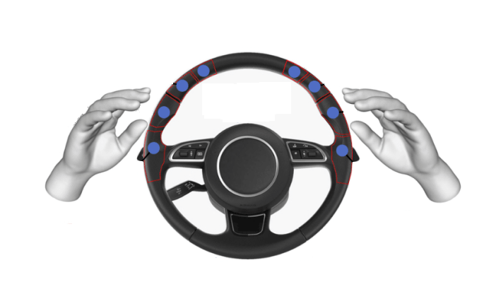

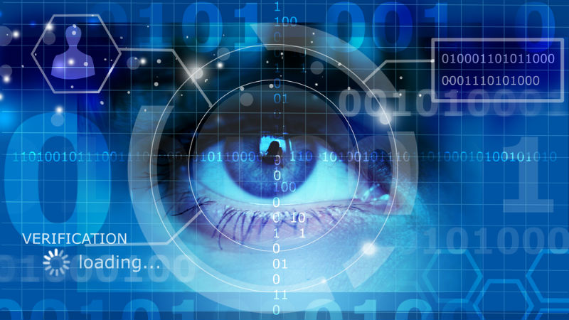

**Biometrics of driver are scanned and the behavior is also matched like machine learning happens in *alexa* *speaker***

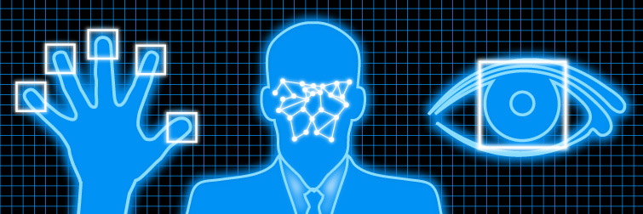

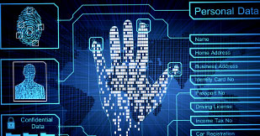

**Working of smart digital license**

In this smart vehicle the teenagers will be away from miss happening’s due to driving.

If any teenager wanted or tries to handle the vehicle then his/her identity will be scanned and matched with smart digital license if he is having the license then vehicle will start and he can drive otherwise not.



**46**

**Children die every day on Indian roads**

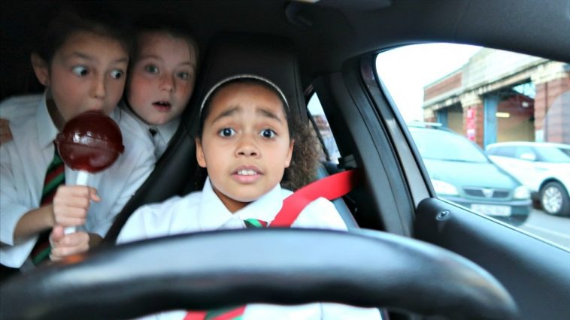

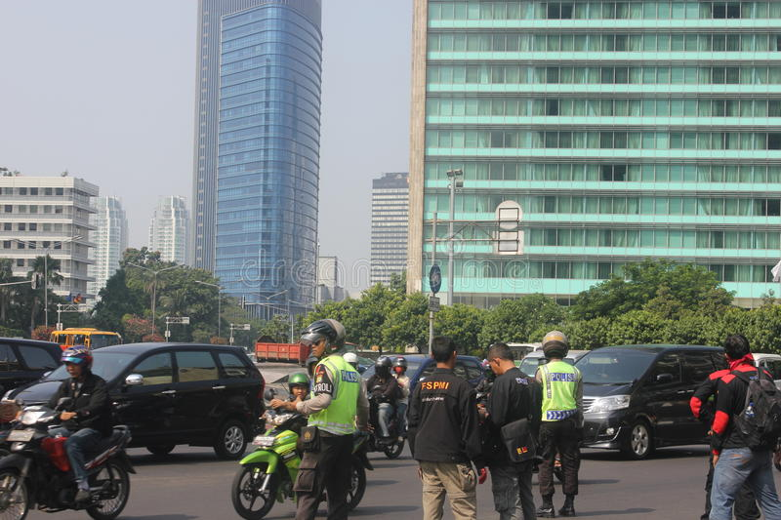

Problems of due to physical license

* On some particular areas like red lights there is a huge traffic jam due to license checking by the police (traffic police). Due to this heavy traffic jam people get late for their work and large amount of fuel (Petrol, Diesel, CNG) is wasted every day.
* In several accidents teenagers or peoples are caught driving the vehicles without license and they are untrained. Many of them tries not to pay the fine by rush driving and due to this many policeman are hurt or have to lose their life for no reasons.

Vehicle security

Vehicle security is the biggest problem in India . There are many cases in which people’s vehicles are stolen from the parking area……, etc.

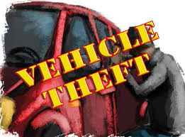

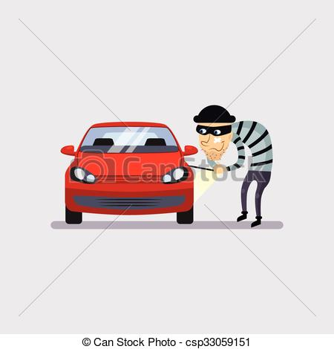

**Solution for problem**

If any unknown person or thief tries to handle your vehicle then their identity will be scanned and forward for verification to government database and it didn't matches so , the vehicle will start and the owner of the vehicle will get a instant notification on his DRIVE APP that his/her vehicle is in hands of any stranger . The owner can take an action like stopping the car at that moment and can reach the place by following the location received on the notification . Owner of the vehicle can also forward the strangers identification to the police by DRIVE APP.

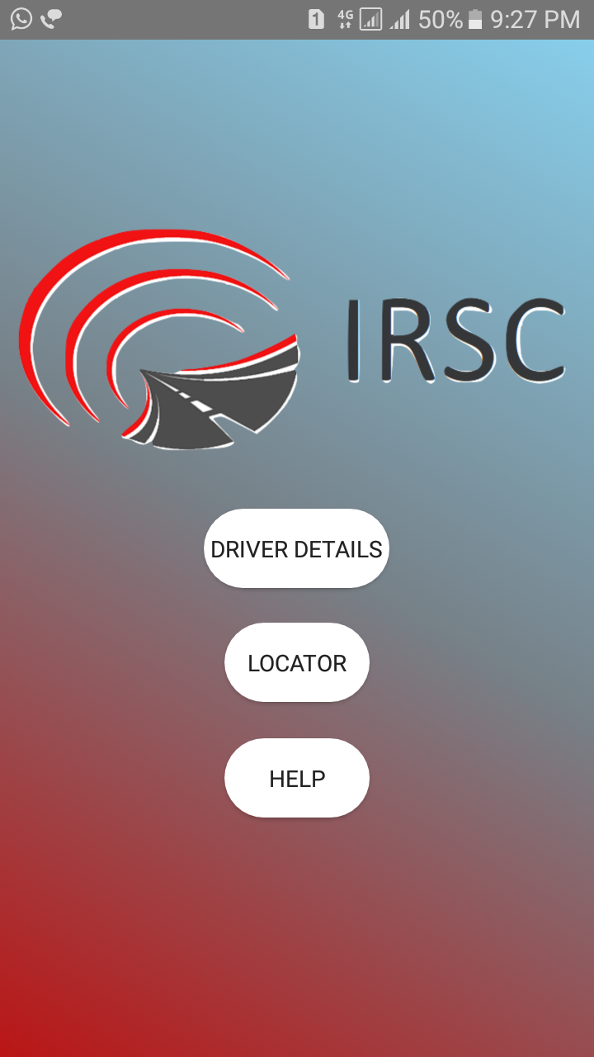 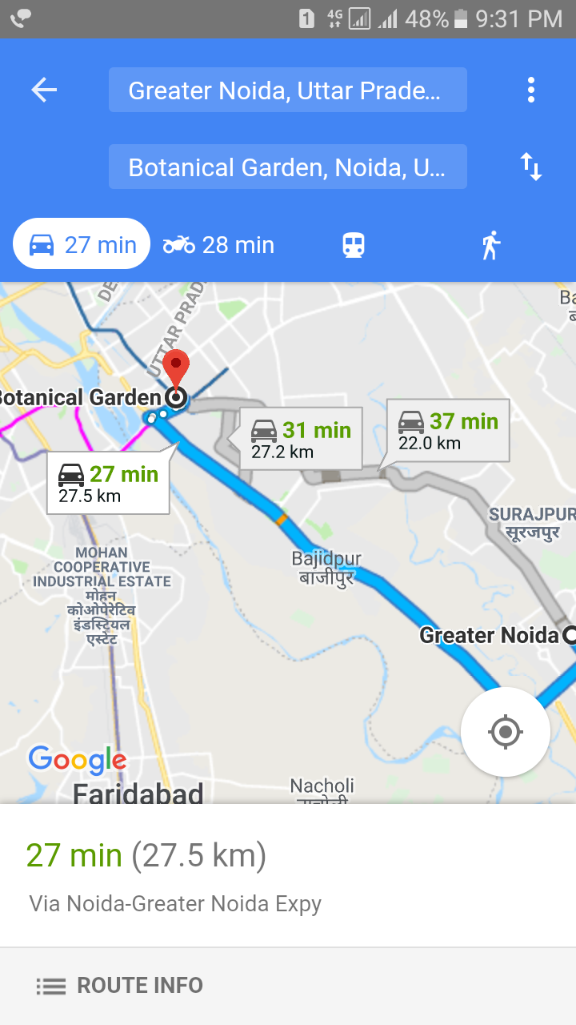

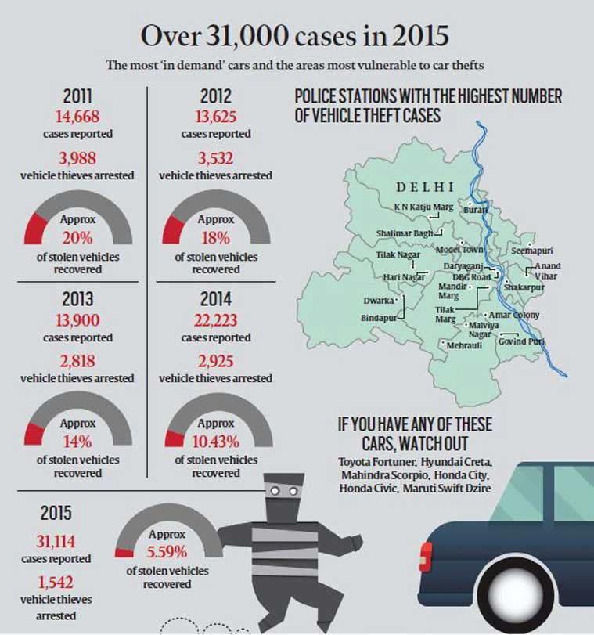

**prevention of drunk and drive cases**

Our smart staring wheel will be provided with hi-tech(sensors) artificial intelligence which is going to learn the behavior of driver in normal conscious time and sensors will detect that the driver is conscious to drive or not . If the driver is conscious to drive the sensors will confirm it and the vehicle engine will be activated to move further. In case of driver is not conscious (by taking alcohol or any other kind of drug) then the vehicle engine will not be activated.

By using this formula we can prevent drunk and drive cases.

**Help button on the drive app**

Our smart driving app will be provided with a help button . It’s function is to provide a instant help to drivers in case of any miss happenings or any road accidents.

 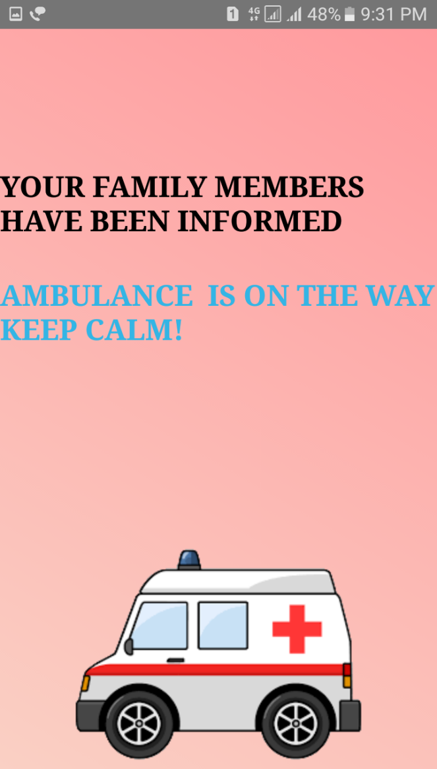

**Working of button**

The DRIVE APP has a HELP button which can be used in case of any miss happenings(accident) person will click the help button. A automatic message will be generated and forward to the near hospital and to there family members . After sending of the message an automatic call will also be generated only to the family members because nowadays many people actually don’t see the message box . 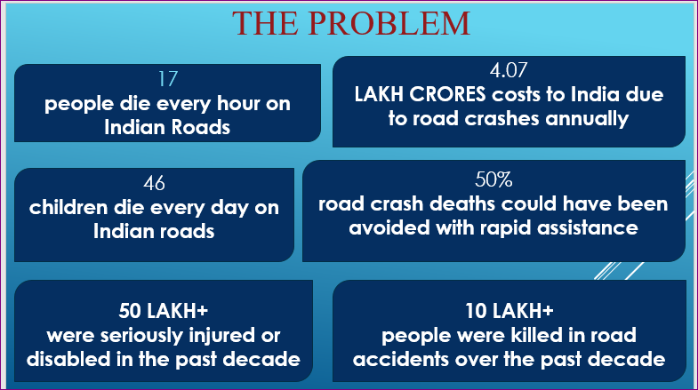

**Working of hospitals in accidents**

All the hospitals of India have to appoint a group of 10 special members who will work for this movement. The appointed team will be consisted of 2 doctors ,4 nurses/ward boys,2 ambulance drivers ,2 extra members to coordinate the team,2 ambulance .

In rural areas the group will consist of 5 members.

The rule to appoint a special team for each (government and private) hospital in India will be compulsory.

**Working of the team**

Whenever any person will click on the help button a message with accident location will reach to the special team of the nearby hospital and to there family members.

The special team will take action by sending the ambulance to the accident area.

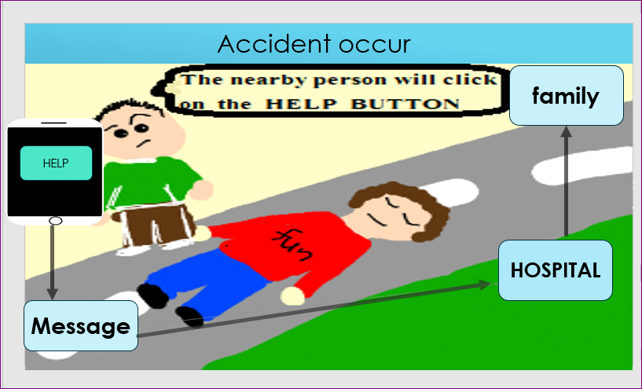

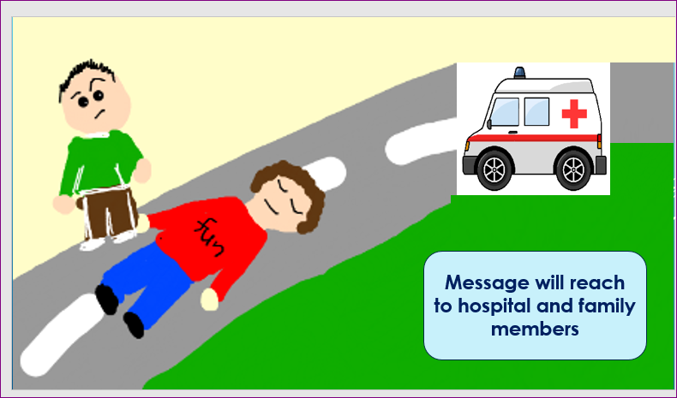

**IT WILL BE THE GREATEST MOVE TOWARDS THE SMART DIGITAL INDIA**

**SMART DRIVE SAVE LIFE**